Unit 8 test
Vocabulary
Vocabulary
1 Look, read and tick ().
1 throw
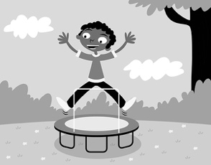 | 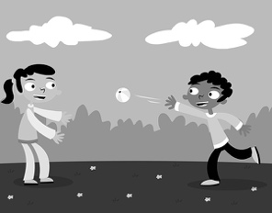 | 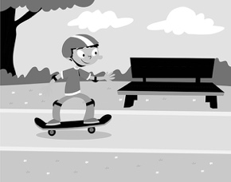
A ☐ | B ☐ | C ☐
2 kick
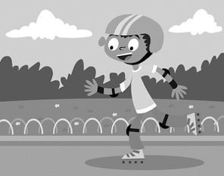 | 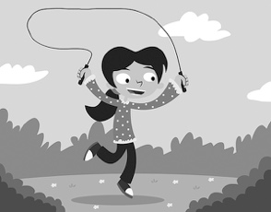 | 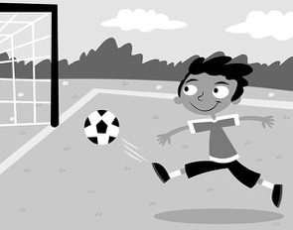
A ☐ | B ☐ | C ☐
3 ride a bike
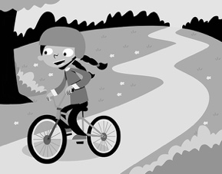 | 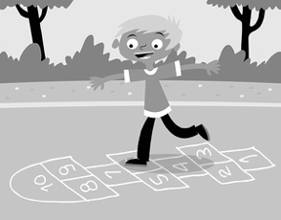 | 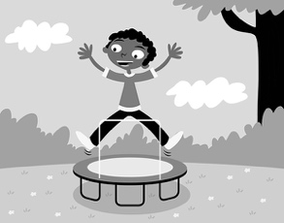
A ☐ | B ☐ | C ☐
/ 3
2 Look, read and circle.
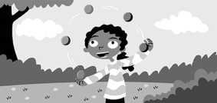 | 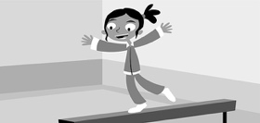 | 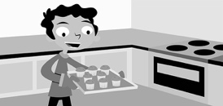 |  | 1 juggle / act  2 paint / do gymnastics  3 play / bake cupcakes  4 paint / juggle pictures  5 juggle / act  6 play / bake the keyboard
1 | 2 | 3
 | 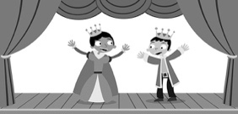 | 
4 | 5 | 6
/ 6

Grammar
3 Look, read and write do, don’t, does or doesn’t.
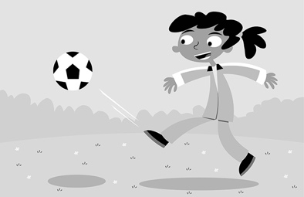 | 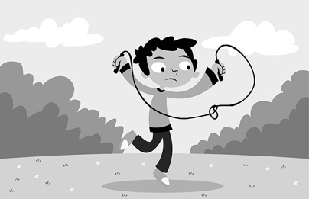 | 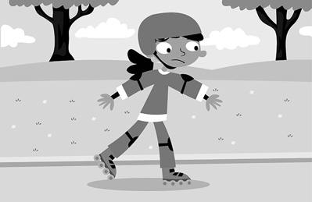
1 Does she like kicking  a ball?  Yes, she . | 2 Do you like skipping, Pat?  No, I . | 3 Does she like rollerblading?  No, she .
 | 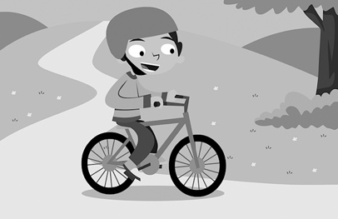 | 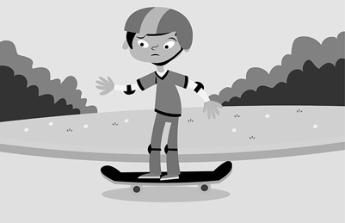
4 Does he like  bouncing?  Yes, he . | 5 Do you like riding  a bike, Lin?  Yes, I . | 6 Does he like skateboarding?  No, he .
/ 6
4 Read and tick ().
1 I’m good at rollerblading. … you good at rollerblading?
A ☐ Are B ☐ Am
2 … you good at acting? No, I’m not.
A ☐ Is B ☐ Are
3 Are you good at skipping? No, I … .
A ☐ ’m not B ☐ am
4 Are you good at juggling? Yes, I … .
A ☐ ’m not B ☐ am
5 Are you good at painting pictures? … am.
A ☐ Yes, you B ☐ Yes, I
/ 5

Reading
5 Read and circle T (true) or F (false).
Home About me Famous dances Links
The grass dance, by Dakota
In Iowa, in the USA, we have a celebration every year. It’s a celebration for children and adults, too. We have a party, and we do lots of dances. My favourite dance is the grass dance. It’s a famous dance from Iowa. It’s fun!
Look! My father is wearing a special costume. It’s red and white.
He’s wearing a big hat. It’s yellow and blue. He’s wearing grass, too!
He’s doing the grass dance with his friends. They’re hopping and bouncing!
Lots of people are watching! My father likes dancing.
1 The blog is about a special dance. T / F
2 Dakota lives in the USA. T / F
3 The celebration isn’t for children. T / F
4 Dakota’s father is wearing a red and white costume. T / F
5 His father doesn’t like dancing. T / F
/ 5
Writing
6 Rewrite the sentences with an adjective or noun.
1 (famous) It’s a dance.
2 (hat) He’s wearing a big.
3 (beautiful) I’ve got a costume.
4 (green) It’s grass.
5 (boots) She’s wearing special.
/ 5

Listening
7  8 What is Priti good at? Listen and circle the tick () or the cross ().
 | 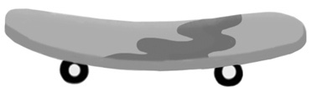 | 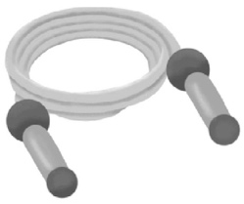
1 / | 2 / | 3 /
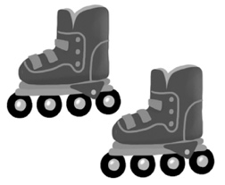 | 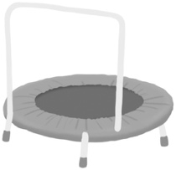
4 / | 5 /
/ 5
Speaking
8 Look and answer.
Are you good at …
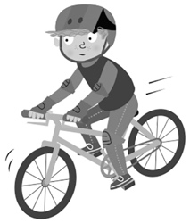 | 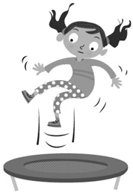 | 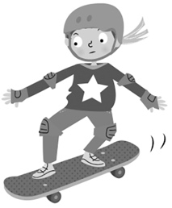 |  | 1 riding a bike?  2 bouncing?  3 skateboarding?  4 kicking a ball?  5 rollerblading?
1 | 2 | 3
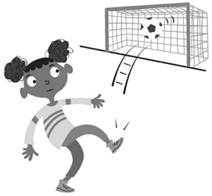 | 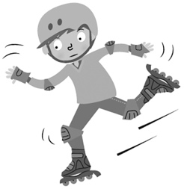
4 | 5
/ 5
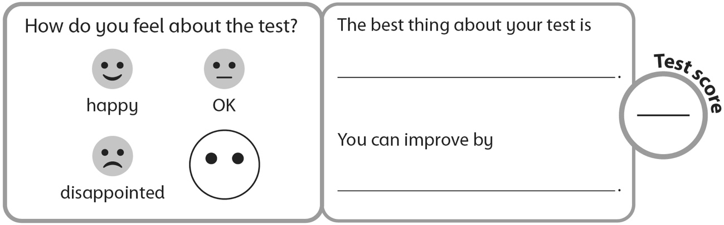
40

